## 1.3 DESIGN CALCULATIONS

The restaurant’s kitchen work for cooking is been split to 8 different locations, proposedly having to design 8 separate kitchen hoods as per the appliances used at that particular location. As per the location of appliances along-side of the wall, a wall type canopy is being selected and further designed as per the ASHRAE and Client requirements.

The design & selection can be done for the different systems and accessories for a commercial kitchen hood. The project hereon details on the exhaust and make up air requdirement with duct sizing for each to maintain the air flow system.

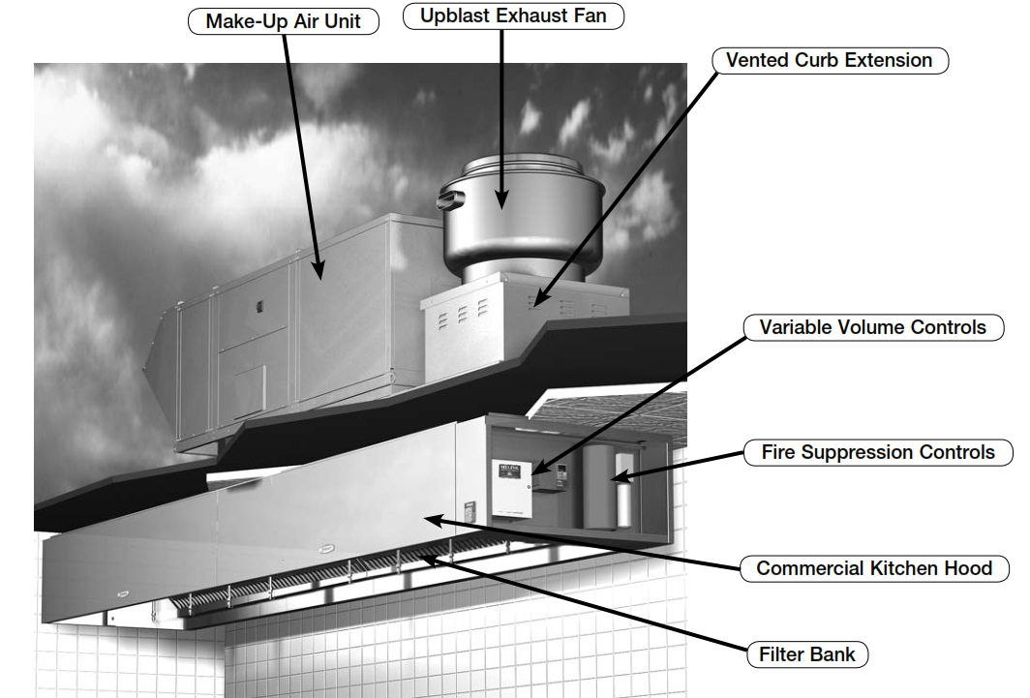

*Fig. 1.1: Wall Canopy – Commercial Kitchen Hood System*

**KITHCHEN HOOD -1:**

Appliances Used:

* + **Fryer (750x750mm) & Oven (900x900mm)**
  + Total length of the cooking appliances is 1650mm.
  + Type of Duty: Medium

Hood Design:

* + Hood covers the entire appliances and further overhang space on sides and front of 150mm (6”).
  + Total Hood length = Overhang + Total appliance length + Overhang

= 150 + 1650 + 150 = 1950mm. = 6.39 ft.

* + Exhaust flow rate = Hood Length x CFM per linear foot (Duty)

= 6.39 x 300 = 1918CFM = 1920 CFM.

* + Exhaust Duct Size as per commercial kitchen exhaust 1800fpm.

300mmx300mm.

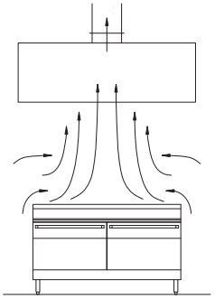

*Fig. 1.2: Exhaust air - Kitchen Hood*

Make-Up Air:

* + Fresh Air = 80% of Exhaust Air

= 1920 x 0.8 = 1536 CFM

* + Fresh Air Duct Size is 300x300mm
  + Grill selected for air flow at the hood (Compensating Hood).

**KITHCHEN HOOD -2:**

Appliances Used:

* + **Griddle (900x750mm) & Oven (900x900mm)**
  + Total length of the cooking appliances is 1800mm.
  + Type of Duty: Medium

Hood Design:

* + Hood covers the entire appliances and further overhang space on sides and front of 150mm (6”).
  + Total Hood length = Overhang + Total appliance length + Overhang

= 150 + 1800 + 150 = 2100mm. = 6.88 ft.

* + Exhaust flow rate = Hood Length x CFM per linear foot (Duty)

= 6.88 x 300 = 2065 CFM.

* + Exhaust Duct Size as per commercial kitchen exhaust 1800fpm.

350x350mm.

Make-Up Air:

* + Fresh Air = 80% of Exhaust Air

= 2065 x 0.8 = 1652 CFM

* + Fresh Air Duct Size is 300x300mm
  + Grill selected for air flow at the hood (Compensating Hood).

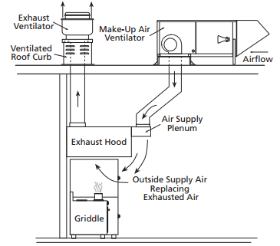

*Fig. 1.3: Make-up air - Kitchen Hood*

**KITHCHEN HOOD -3:**

Appliances Used:

* + **Fryer (750x750mm), Griddle (900x750mm) & Oven (900x900mm)**
  + Total length of the cooking appliances is 2550mm.
  + Type of Duty: Medium

Hood Design:

* + Hood covers the entire appliances and further overhang space on sides and front of 150mm (6”).
  + Total Hood length = Overhang + Total appliance length + Overhang

= 150 + 2550 + 150 = 2850mm. = 9.34 ft.

* + Exhaust flow rate = Hood Length x CFM per linear foot (Duty)

= 9.34 x 300 = 2800 CFM.

* + Exhaust Duct Size as per commercial kitchen exhaust 1800fpm.

400x400mm.

Make-Up Air:

* + Fresh Air = 80% of Exhaust Air

= 2800 x 0.8 = 2240 CFM

* + Fresh Air Duct Size is 350x350mm
  + Grill selected for air flow at the hood (Compensating Hood).